MONDAY EXERCICES

## Q1 HTML Formatting

|  |  |  |
| --- | --- | --- |
| **Tags** | **Display** | **Match** |
| A. <strong>Text here</strong> | 1. Text here | A 3 |
| B. <em> Text here </em> | 2. *Text here* | B 2 |
| C. <del> Text here </del> | 3. **Text here** | C 4 |
| D. <u> Text here </u> | 4. ~~Text here~~ | D 1 |

## Q2 Ordered list

<ol>

<li>Item here</li>

</ol>

|  |  |  |
| --- | --- | --- |
| **Types** | **Display** | **Match** |
| A. list-style:none; | 1/ a. Item here | A 4 |
| B. type=”a”; | 2/ I. Item here | B 1 |
| C. type=”A”; | 3/ 1. Item here | C 5 |
| D. type=”I”; | 4/ Item here | D 2 |
| E. type=”i”; | 5/ A. Item here | E 6 |
| F. type=”1”; | 6/ i. Item here | F 3 |

## Q3 Unordered list

<ul>

<li>Item here</li>

</ul>

|  |  |  |
| --- | --- | --- |
| **Type** | **Display** | **Match** |
| A. list-style:**none**; | 1/ Item here | A 3 |
| B. list-style:**disc**; | 2/ Item here | B 1 |
| C. list-style:**circle**; | 3/ Item here | C 4 |
| D. list-style:**square**; | 4/ Item here | D 2 |

## Q4 Cascading Style Sheets

|  |  |  |
| --- | --- | --- |
| **Type** | **Display** | **Match** |
| A. <link rel=”stylesheet” href=”main.css” /> | 1/ Inline style sheet | A 2 |
| B. <style>  body { background: green; }  </style> | 2/ External style sheet | B 3 |
| C. <h1 style=”color:blue;”>Heading 1</h1> | 3/ Internal style sheet | C 1 |

## Q5 Hyperlinks

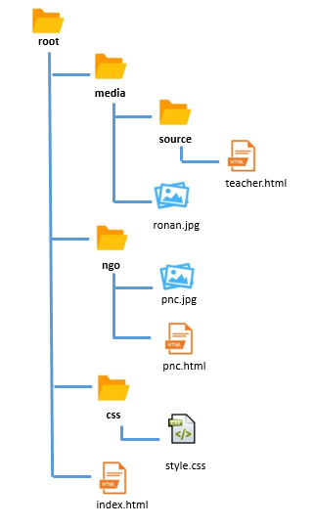

A. Write the link from **index.html** to **style.css**

css/style.css

B. Write the link from **index.html** to **teacher.html**

media/source/teacher.html

C. Write the link from **pnc.html** to **teacher.html**

../media/source/teacher.html

D. Write the link from **pnc.html** to **ronan.jpg**

../media/ronan.jpg

E. Write the link from **teacher.html** to **pnc.jpg**

../../ngo/png.jpg

F. Write the link from **teacher.html** to **style.css**

../../css/style.css

## Q6

Complete the CSS code to fulfill requirements.

|  |  |
| --- | --- |
| HTML | Browser |
| <body>  <a href=”#” >pnc cambodia</a>  </body> | **PNC CAMBODIA** |

|  |
| --- |
| CSS |
| a {      font-family: sans-serif;      text-transform: uppercase;      text-decoration: none;      font-weight: bold;      color: #0b74d6  } |
| Help |
| * The text shall be bold with a sans-serif font |

## Q7

Complete the CSS code to fulfill requirements.

|  |  |
| --- | --- |
| HTML | Browser |
| <body>  <div class=”tealBox”></div>  </body> |  |

|  |
| --- |
| CSS |
| .tealBox {      width: 200px;      height: 200px;      background: teal;  } |
| Specifications |
| * The teal box shall be the same width and height [200px] |

## Q8

Complete the CSS code to fulfill requirements.

|  |  |
| --- | --- |
| HTML | Browser |
| <body>  <div id=”circle”></div>  </body> |  |

|  |
| --- |
| CSS |
| #circle {      width: 200px;      height: 200px;      background: green;      border-radius: 50%;  } |
| Specifications |
| *div circle :*   * The green circle shall be the same width and height [200px] |

## Q9

Complete the CSS code to fulfill requirements.

|  |  |
| --- | --- |
| HTML | Browser |
| <body>  <div class=”orangeBox”></div>  </body> |  |

|  |
| --- |
| CSS |
| .orangeBox {      width: 200px;      height: 200px;      background: orange;      display: flex;      justify-content: center;      align-items: center;      font-family: sans-serif;      font-weight: bold;      color:#fff;  } |
| Specifications |
| * The text in orange box shall be centered vertically and horizontally * The orange box text shall be bold with a sans-serif font |

## Q10

Complete the CSS code to fulfill requirements.

|  |  |
| --- | --- |
| HTML | Browser |
| <body>  <div class="box one">Box One</div>  <div class="box two">Box Two</div>  <div class="box three">Box Three</div>  </body> |  |

|  |
| --- |
| CSS |
| body { display: flex; }  .box {      width: 200px;      height: 200px;      display: flex;      justify-content: center;      align-items: center;      font-family: sans-serif;      font-weight: bold;      color:#fff;      margin-left: 10px;  }  .one { background: orange;}  .two {background: teal;}  .three {background: blue;} |
| Help |
| * The all box shall be the same width and height [200px] * The text in all box shall be centered vertically and horizontally * The orange box text shall be bold with a sans-serif font |